Northern Cancer Alliance Advice

Primary Care Network Service Specification – Early Cancer Diagnosis
(Service Specification to Commence 1st October 2020)

This PCN service specification overlaps with practice QOF quality improvement, QI005, Q1006 Early cancer diagnosis and QI007 Learning disability.

The Northern Cancer Alliance (NCA) is tasked to improve patient cancer outcomes including increased cancer survival and patient experience of cancer. It is a multi - agency collaborative including primary care. The new Primary Care Network (PCN) service specification includes Supporting Early Cancer Diagnosis. Core elements of the specification are outlined below. The specification is linked to the by quality improvement included in QOF for 2020-21. This includes Early Cancer Diagnosis and Learning Disability.

The NCA with support from Cancer Research UK Facilitators are offering some guidance to support PCNs in agreeing what and how they will meet this service specification. The support offer includes; overview of specification requirements, suggestions for PCN activity – for ideas generation, off the peg tools and signposting to resources, support for CCG Cancer Leads, PCN page on the Alliances website. If you would like the assistance of the CRUK Facilitators and Alliance GP Cancer leads please contact us, contact details below. The advice, guidance and suggestions within this document provide have been guided by the NHS England and NHS Improvement specification.

What the PCN Specification Covers and Asks
The PCN service specification covers three core components:

Component | In more detail….
Review Referral Practice | Enabling and supporting practices to consider  Referral  - Review practice level data to explore presentation and diagnostic trends  - Review the quality of suspected cancer referrals (in line with NICE NG12)  - Make use of and available Clinical Decision-Making Tools  - Make use of Rapid Diagnostic Pathways for Vague Symptoms  Safety Netting  - Building on current practice to ensure a consistent approach in monitoring patients who have been referred urgently  - Or for follow up for further investigations to exclude the possibility of cancer  Patient Information:  Ensuring that all patients are signposted to or receive  - Information on their referral including why they are being referred,  - Information on the importance of attending appointments  - Information on where they can access further support.
Increase Uptake of the National Cancer Screening Programmes | Working with NCA and Public Health Commissioners agree the PCN contribution to local efforts to improve screening uptake (cervical, breast and bowel)  - Review screening data  - Build on any existing actions across PCN practices  - Include at least one specific action to engage a low participation group; locally.
Improve outcomes through reflective learning and local system partnerships | Develop a community of practice across clinical staff that will support your practices to have peer to peer learning events that;  - Look at data and trends in diagnosis across the Network  - Reflect on cases of late diagnosis and repeated patient presentation before referral

What Does the QOF Early Cancer Diagnosis Cover :
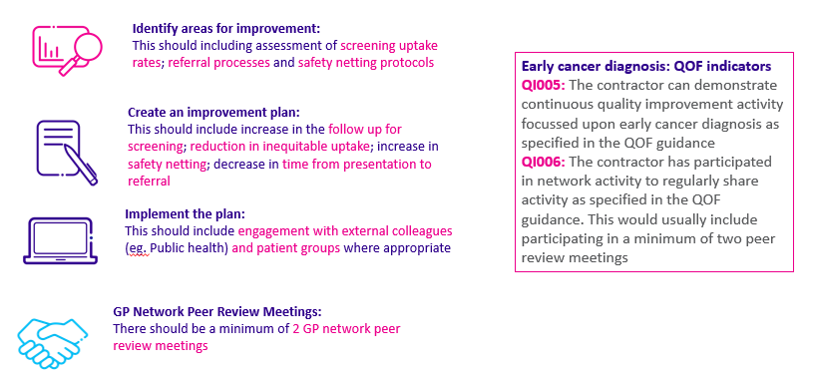
Practices are expected to undertake quality improvement activity in both screening and early diagnosis. This quality improvement activity will support existing efforts of local public health commissioning teams and Cancer Alliances and will contribute to the success of Integrated Care Partnership (ICP) and NHS Long Term Plan commitments.

Taking the PCN Specification Forward - Suggestions for PCN Activity and Projects

- Review of Referral Practices for Suspected Cancer Referrals
Contribution to PCN Specification | Suggested Activity - Options | Quick Hints, Tips and Tools
Audit Activity
Audit enables practices to see what is working well and any areas that need improvement.
Consider auditing and then sharing anonymised learning at peer review.
Review and improve referral practices  Improving Outcomes Through Reflective Learning  Review and improve referral practices  Improving Outcomes Through Reflective Learning | Auditing of New Cancer Diagnosis  This is a great way to review how cancer is diagnosed in practice. Are the practice referrals meeting the NICE 12 guideline?  The PCN should agree which cancers should be included based on local needs and local data. Do not forget to include patients who have died or moved practice in the audit.  - Audit and then share anonymised learning at a peer review session. The audit should look for delays in the cancer diagnosis, this includes patient delays, primary care delays or secondary care delays.  - Delays can be related to diagnostics (not having urgent results within 14 days) or system delays failure to arrange a test or a referral.  - Practice should agree a plan to reduce any identified delays or issues  Examples of audits include -  - Patients diagnosed by emergency admission (these patients have a poor prognosis).  - A specific tumour pathway for example Lower GI (high incidence, difficult pathway) Lung, Urology, Breast or Upper GI (other high incidence cancers).  - 20 consecutive new cancers (including patients diagnosed during the COVID19 pandemic – could also support safety netting)  - Patients referred with serious but non-specific symptoms of cancer  - Other PCN agreed groups  The National Cancer Diagnosis Audit (NCDA) outlined below and the Royal College of General Practitioners - Significant Event Analysis toolkit (opposite) provide the frameworks for these types of audit. NB. The NCDA has nationally set audit criteria and fields.  To support your own audit you will need to create a search on the clinical system for all neoplasms within a set time period. | Use the Gateway C – Improve the Quality of Referral Module (E-learning) to help get started. Gateway C Module  See the RCGP Toolkit link for SEAs Toolkit : RCGP SEA Video
 | National Cancer Diagnosis Audit (2019/2020) – Extended Due to COVID19  - Register /Already Registered – Complete case reviews Auditing Diagnosed Cancer Case.  - Convene Reflective Peer Review Workshop at either practice or PCN level.  This national audit tool - automatically identifies confirmed patient cases for audit between Jan - Dec 2018. On line portal with readymade questions and fields which enable a review and produces a final report of results. Covering presentation, patients’ routes to diagnosis, stage at diagnosis, analysis of any delays in care, flag for SEA.  - Deadline for Case Submissions 31st August 2020.  - Audit reports available October 2020  - Summary Presentations and via CRUK Facilitators | National Cancer Diagnosis Audit  Contact your Cancer Research UK Facilitator for support and advise on registration, use and audit reports.
 | Auditing 2ww Referrals Forms (Referral Completeness/Reducing Pathway Delays)  Completeness of referral. Incomplete referral forms cause delay and difficulty when secondary care plan further investigations and management. Does the form -  - Meet the 2WW referral criteria  - Reason for referral – having the full picture is essential to enable secondary care investigation and management  - Patients performance status – to help plan which is the most appropriate set of investigation  - *COVID 19 Risk Status – COVID19 risk identified to assist with triage during pandemic  - Timely bloods when appropriate – not having UEs may delay CT etc | Example Audits on the Northern Cancer Alliance Website or ask CRUK Facilitator Cancer GP for assistance.
Review and improve referral practices  Improving Outcomes Through Reflective Learning  Review and improve referral practices  Improving Outcomes Through Reflective Learning | Audit of supporting patients though the 2WW referral process by provision of the 2WW leaflet (in conjunction with one of the above) *Note that these forms have been updated to include COVID 19 advice.  Audit to see what percentage of patients are given patient information leaflets and safety netting advice at the point of 2WW referrals.  Providing patients with the 2 WW information leaflet helps patients understand the importance of attending urgent cancer referrals.  It also helps safety net the referral process when there are unexpected delays reducing complaints and improving communication. | Example Audits on the Northern Cancer Alliance Website or ask CRUK Facilitator Cancer GP for assistance.
Safety Netting (SN)
Safety netting should reflect three core elements (Oxford University Safety Netting Model) : Patient Communication, GP Actions During Consultation, Practice Processes and Systems
 | Implementing practice safety netting procedures in primary care. Safety netting is important part of cancer referrals and investigations.  Review Safety Netting Practices - PCNs should support practices to review their safety netting processes. Could PCNs agree some standard processes and principles across the PCN? Support update and learning sessions including – using review tools such as the Oxford Safety Netting Tool.  Ensure recently issued Northern Cancer Alliance COVID19 Safety Netting Guidance has been used to consider current practice and potential enhancements. N.B. New Safety Netting Guidance and Tools were issued by the Cancer Alliance in March 2020.  Consider the use of safety netting templates within clinical systems.  When practices audit their cancer diagnoses it can often show occasions where there are delays in investigation and referral for a variety of reasons. These delays can be related to patients, clinical or system failure. Safety netting can minimise this risk. Safety Netting examples opposite. | Ask your CRUK Facilitator to provide tools and support sessions.  Download CRUK Safety Netting Insights  CRUK Cancer Insights Safety Netting  Macmillan Safety Netting Tools – Mac 10 Top Tips  Safety Netting Examples
Clinical Decision-Making Tools
Compliance with NG12 NICE Guidance
 | Clinical Decision Support Tools  Possible Actions / Activities  - PCN hosts a session on clinical support tools as part of peer support  - PCNs create opportunities to signpost- support peer learning for their trainees re NG12 Guidance, E-Learning modules and Clinical Decision tools  - Practices agree to use a clinical decision support tool including an audit of use and outcomes.  There are tools being developed to support primary care in investigation of symptoms which could be cancer related. For example, a lower GI symptom checker for SystmOne is being developed | Q Cancer (EMIS practices) https://www.qcancer.org/
 | Serious but non-specific symptoms of cancer
The use of Clinical Decision Support Tools and / or “Vague symptoms” (also called Serious but non-specific symptoms of cancer pathways) and / or Rapid Diagnostic Centre pathway. This depends on the service available locally. The Gold standard is the Rapid Diagnostic Centre (RDC) pathway but many areas do not have this in place. Consider-
- Practices are aware of and uses their local RDC if there is a RDC pathway
- Where there is no RDC pathway, practices are aware of and use their local “vague symptoms” or Serious but non-specific symptoms of cancer pathway if this is available.
- Where there is no RDC or vague symptoms pathway the practices are aware of and use decision support tools such as Q cancer.

- Contribute to improving local uptake of National Cancer Screening Programmes
Contribution to PCN Specification | Suggested Activity Options | Hints, Tips and Tools
Improve Screening Uptake
The new contract promotes reducing health inequalities – improving screening can do this. This is important for patients with learning disabilities.
Improving Screening  Uptake  Cervical, Bowel and Breast Screening | - PCNs agree to review their current screening data – Data sets available from CRUK Facilitators or consider inviting public health or screening to help this process.  - PCNs agree their priorities and plan based on inequalities and screening uptake. Plans need to be SMART.  - PCNs participate in peer review sharing what works well etc, see section 3 supporting delivery – peer support /community of practice  Examples include:  - Work with your CRUK Facilitator to review and adopt aspects of CRUK Cervical and Bowel Screening Good Practice Guides  - Increasing cervical screening attendance – this could be achieved by practices contacting non-attenders, or PCN arranging extra shared clinics, which may be more convenient for patients.  - Continued support for the regional “Cervical Screening Saves Lives” campaign  - Supporting patients with Learning Disabilities to access screening, by sharing patient details with bowel screening hub  - PCN working with local community groups to reach the hard to reach groups, based on local data and knowledge, noting that screening levels are lower in patients whose first language is not English.  - PCNs support a collaborative project across practice Non – Clinical Cancer Champions – to focus on improving screening for specific patient groups. | Link to what is expected of constituent practices- Improvement planning in the Cancer QOF QI .  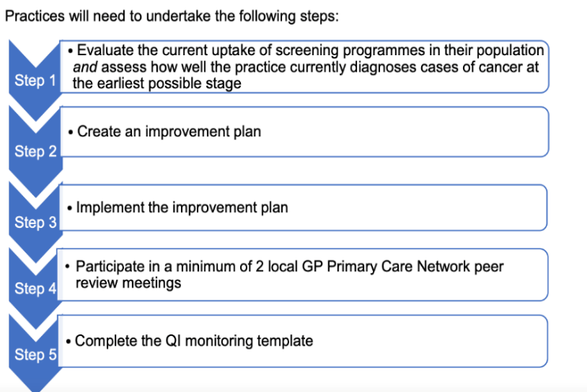  Access the CRUK Screening Guides  Engage with regional Screening and Imms work  Consider the assets you already have e.g. Non-Clinical Cancer Champions, Social Prescribers  Link to ongoing LD initiatives  Review the NHSE and NHSI Case Studies
- Support the delivery of 1) and 2) through a community of practice
Contribution to PCN Specification | Suggested Activity Options | Hints, Tips and Tools
Improve outcomes through reflective learning and local system partnerships | Supporting Referral and Screening Work Through a Community of Practice  One of the roles of the PCNs is to ensure that good practices are shared and implemented as widely as possible
 | Peer review and support is essential in this process., but it should constructive to improve practice working and to improve patient care. Peer view and support should be constructive to improve practice working and patient care. It should include-  - Creating opportunity for practices to meet and share their improvement plans  - Plans should have SMART objectives i.e. Specific, Measurable, Achievable and Time - bound  - At the peer review meetings, practices should share learning and amend their cancer improvement plans  - The PCNs should have 2 peer review meetings before April 2021. (Was the standard when the specification was due to start in April 2020). | Access support and advice available to facilitate sessions i.e. GP Cancer Leads, CRUK , Northern Cancer Alliance GP Leads.

Supporting the Quality Improvement Process
Some PCNs and practices may wish to agree their own plans. To support this the Alliance has produced templates for improvement plans and access to some basic quality improvement tools. The Northern Cancer Alliance has some further worked up examples of improvement plans that may help around the referral and screening topics.
If the Northern Cancer Alliance can support your PCN in this Early Cancer Diagnosis specification, please contact us. See contact details below.

Katie Elliott | CRUK GP Primary Care Clinical Director NCA | katieelliott@nhs.net
Chris Tasker | CRUK GP NCA lead for PCN work | chris.tasker@nhs.net
Fiona McQuiston | CRUK Facilitator Manager | fiona.mcquiston@cancer.org.uk
Angela Atkinson | CRUK Facilitator | angela.atkinson@cancer.org.uk
John Gorman | CRUK Facilitator North Cumbria | john.gorman@cancer.org.uk
Sarah Kucukmetin | CRUK Facilitator | sarah.kucukmetin@cancer.org.uk
Sharon Smith | CRUK Facilitator | sharon.smith@cancer.org.uk

Chris Tasker
CRUK GP June 2020
Supporting documents
Contract Documents
www.england.nhs.uk/wp-content/uploads/2020/03/update-to-the-gp-contract-agreement-v2-updated.pdf
www.england.nhs.uk/wp-content/uploads/2020/03/cover-note-gps-commissioners-revised-network-contract-des.pdf
www.england.nhs.uk/wp-content/uploads/2020/02/20-21-qof-qi-cancer.pdf
www.england.nhs.uk/wp-content/uploads/2020/02/20-21-qof-qi-cases-studies.pdf
www.england.nhs.uk/wp-content/uploads/2020/02/20-21-qof-qi-supporting-people-with-learning-disabilites.pdf

Suspected Cancer: recognition and referral
www.nice.org.uk/guidance/ng12

CRUKs PCN Specification Hub.
www.cruk.org/GPcontract -

Macmillan Specification
www.macmillan.org.uk/about-us/health-professionals/resources/resources-for-gps.html
www.rcgp.org.uk/clinical-and-research/resources/a-to-z-clinical-resources/cancer.aspx

