Northern Cancer Alliance ‘Help Us Help You’
Week 3 communications toolkit
July, 2020

Please find below updated communications materials focusing on Week 3 of our Help Us Help You regional awareness campaign, which will focus on lung cancer.

Website/Intranet copy
Lung cancer specialist calls for people to be aware of the signs of the devastating disease

A leading lung cancer doctor has called on people across the region to contact their GP if they are worried about potential lung cancer symptoms.

Whether it’s a new or changed cough that lasts more than a few weeks, breathlessness, chest pain or unexplained tiredness, it’s important for people to speak to the GP or nurse who will be able to explore the symptoms further.

Diagnosing cancer early can save lives. However, almost three quarters of lung cancers are diagnosed at a late stage. The Northern Cancer Alliance is working hard to try and improve outcomes for people across the region and has recently launched its Help Us Help You campaign.

Across the North East and North Cumbria area covered by the Alliance, incidence rates and mortality rates for lung cancer are the second highest in England when compared to other cancer alliances.

Dr Liz Fuller, Clinical Lead on the Northern Cancer Alliance’s Lung Pathway Board, said: “We know that diagnosing lung cancer early saves lives, but what we’re seeing during the Covid pandemic is fewer people coming into the NHS for tests for lung cancer. I want to reassure people that the NHS is open and can safely test and treat people if required.”

Help Us Help You was launched to reassure people that cancer services remain a top priority for the NHS, and to encourage people not to delay contacting their GP or nurse if they are concerned about signs or symptoms of cancer.

Smoking is the biggest risk factor for lung cancers and accounts for about 72% of lung cancers.
Although smoking prevalence has reduced considerably in recent decades, there is still a significant gap between the least and most deprived groups in our population.

A range of lung cancer information resources and links to stop smoking support services across the region can be found on the ‘Help Us Help You’ webpage at: https://www.northerncanceralliance.nhs.uk/helpushelpyou/resources-information/lung-cancer-help-us-help-you/

ENDS

Social media content
Please follow us on Twitter and tag us in your tweets @NorthernCancer
Post copy | Asset
The North East and North Cumbria has one of the highest lung cancer death rates in England. It’s so important to speak to your GP or nurse if you’re worried about any signs or symptoms that could be cancer @NorthernCancer #HelpUsHelpYou  https://www.northerncanceralliance.nhs.uk/helpushelpyou/resources-information/lung-cancer-help-us-help-you/ | NCA lung symptoms  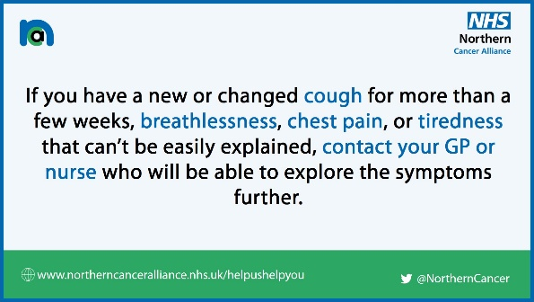
This is an important message from Dr Liz Fuller, a lung cancer doctor @NorthernCancer. Please don’t delay contacting your GP if you have any new, unexplained symptoms that you’re concerned about #HelpUsHelpYou  https://youtu.be/MDe9tio95RU | YouTube link will create thumbnail image
Smoking is the biggest risk factor for lung cancers. If you’re concerned about any possible cancer symptoms or if you’d like to seek support to quit smoking, you can access info via @NorthernCancer’s #HelpUsHelpYou webpages ⬇️  https://www.northerncanceralliance.nhs.uk/helpushelpyou/resources-information/lung-cancer-help-us-help-you/ | NCA smoking figure  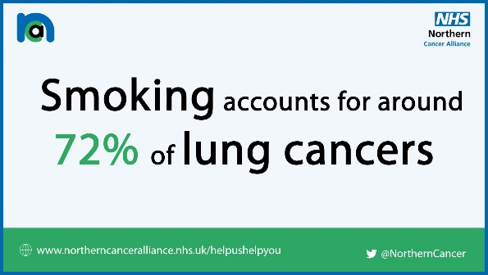
Quitting smoking reduces the risks of 16 types of cancer, heart disease and stroke, as well as reducing the risk of severe complications from COVID-19. There’s never been a more important time to quit – to get started visit TodayistheDay.co.uk #QuitForCovid #COVID19 | Quit for Covid Twitter card  