April 2020 update NCA Advice for GPs for
Suspected cancer referrals during Covid 19 pandemic

All trusts are able to accept and process 2ww referrals.
All trusts are providing cancer treatments based on clinical need.
All trusts can process suspected cancer direct access radiology requests.
All teams and radiology are keen to support GPs with advice and guidance.

It continues to be important to assess and share decisions with patients about immediate clinical need against risk from referral / investigation / treatment, including risk of infection with COVID-19, to minimize harm. This risk assessment is currently on a case by case basis and this will be the same in primary and secondary care.

Suspected cancer referrals
Primary care should continue to refer suspected cancer patients using the current criteria and systems.

2ww referrals cannot be rejected. The policy remains that providers receiving referrals may not downgrade urgent cancer referrals without the consent of the referring primary care professional.

Remember: People who do not meet the referral criteria have < 3% chance of having cancer.
Primary care can support referral management using shared decision making with patients

Use advice and guidance where available

Completeness of referrals
It is essential for patient safety that a full and detailed clinical history is given and the appropriate blood tests, to be able to safely prioritise plan investigations and minimize unnecessary visits to hospitals. Access to blood tests for referrals for suspected cancer must be maintained in primary care and completed before the referral is sent.

ACTION: Do not send incomplete referrals
ACTION: Make sure you are using the most up to date version of the 2ww forms
http://www.northerncanceralliance.nhs.uk/pathway/early-diagnosis/supporting-primary-care/two-week-wait-referral-forms/
2ww forms have been amended to include performance status and risk of COVID 19 for all referrals.

2ww referrals outcomes and safety netting responsibilities
Most contacts will be by telephone as the first appointment, and some patients may have subsequent investigation deferred/suspended until there is lower risk from COVID 19. GPs may be asked to prescribe medication while people are waiting for investigation.

The outcomes and responsibilities for 2ww referrals are:

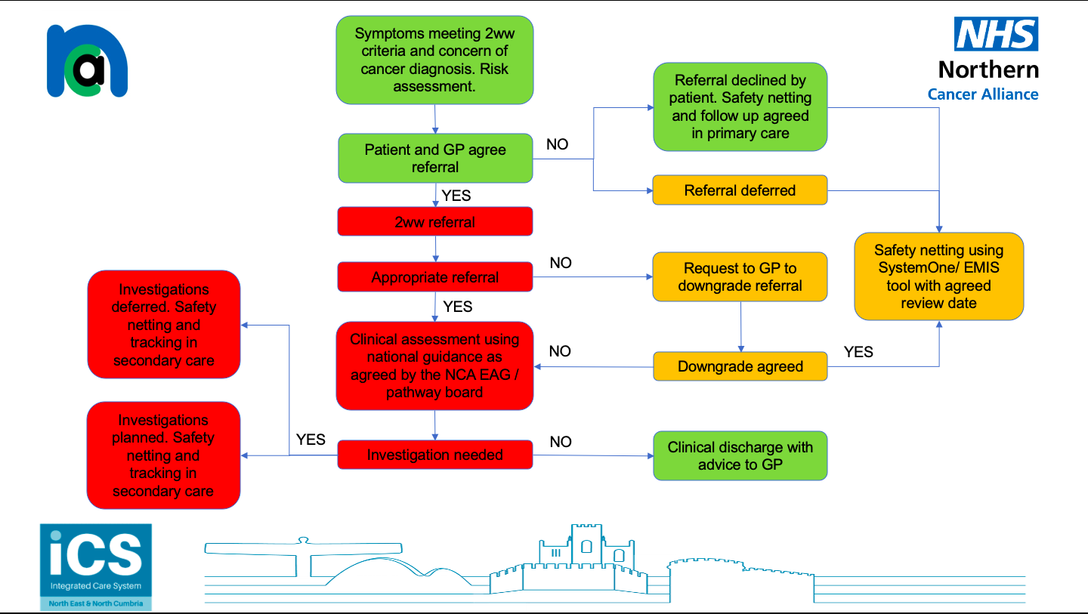

Safety netting
Where referrals are delayed in primary care due to patient choice or self-isolation the referrals need safety netting primary care.

It is essential to give and record your clinical safety netting advice to patients

The regional digital resources group (CDRC) have built templates for SystemOne and EMIS to record deferred activity in primary care and includes the delay reasons.

ACTION: Access and use the new templates and searches. These are available here:

Manage patient expectations
Inform patients about their referral, including for radiology – that the time scale for investigation and management of their symptoms may be different to usual and hospitals will try to plan investigations and treatments depending on clinical needs as well as to protect people from harm.

All the 2ww PIL have been changed to include the additional advice for patients during the Covid 19 pandemic.

ACTION: Use the hyperlink on the 2ww referral for to access the patient information leaflet at the time of making the referral.

https://www.northerncanceralliance.nhs.uk/pathway/early-diagnosis/supporting-primary-care/

Screening
Some screening has been paused and will increase again as safe access to diagnostics expands.
Tumour specific advice
Some additional advice is here and will be updated as needed
https://teamnet.clarity.co.uk/nescn/Topics/View/Details/fee1be83-e3dd-4afd-9a9d-ab8f016ee094

