EMIS Tips 5: Creating Deferred Treatment
Workflow
30 March 2020

Introduction
The COVID-19 pandemic has meant that there is a lack of capacity to be able to provide normal referral and treatment pathways, whether this be referral to an outpatient appointment, minor surgery in practice and so on.
Patients themselves would rather delay until the current incident has been resolved rather than risk exposure to infection (eg the “shielded” very vulnerable group)
And patients themselves may be suffering from possible COVID19 symptoms meaning that they are unsuitable at the time for referral, even for 2 week wait referrals, and there needs to be a delay whilst they recover.
This document describes one process to manage these delayed treatments safely

Resources
COVID19 Delayed treatment : template
COVID19 Delayed treatment Search ALL
COVID19 Delayed treatment search due or overdue

Setting Up
Open and save the resources contained in the ZIP file above

Importing the searches
Navigate to reporting -> population reporting and identify (or create) an appropriate folder.
Using import, upload the two searches:
- COVID19 delayed treatment Search ALL
- COVID19 delayed treatment search due or overdue.
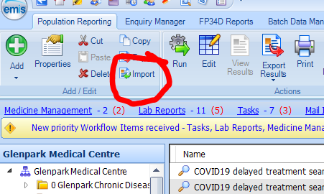
Once imported into EMIS, right click over each in turn and choose properties.
Click on the schedule tab and set the automatic run schedule. IN this instance it has been set to daily and to end after 6 months (hoping that this will all be done and dusted by then!
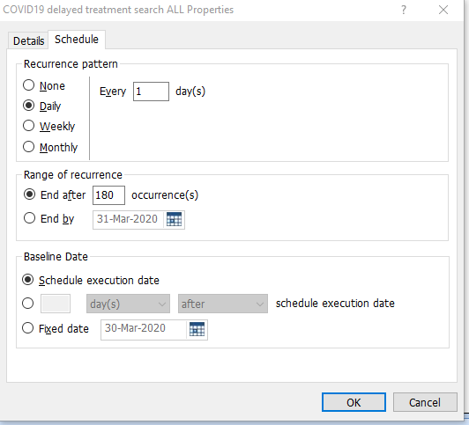

Importing the template
Newcastle Gateshead practices do not need to do this step.
Open up Resource Publisher or template manager and import the template “COVID19 Delayed treatment”
Right click over the template, and set status to “active”

Checking the template is active
For Newcastle Gateshead practices
The template has been published as active to Newcastle and Gateshead. If it is not working in the practice, check that it hasn’t been accidentally deactivated.
Navigate to Resource Publisher Shared folders CBC Health NGCCG templates.
If COVID19 Delayed treatment template is showing as inactive, right click and set status to active
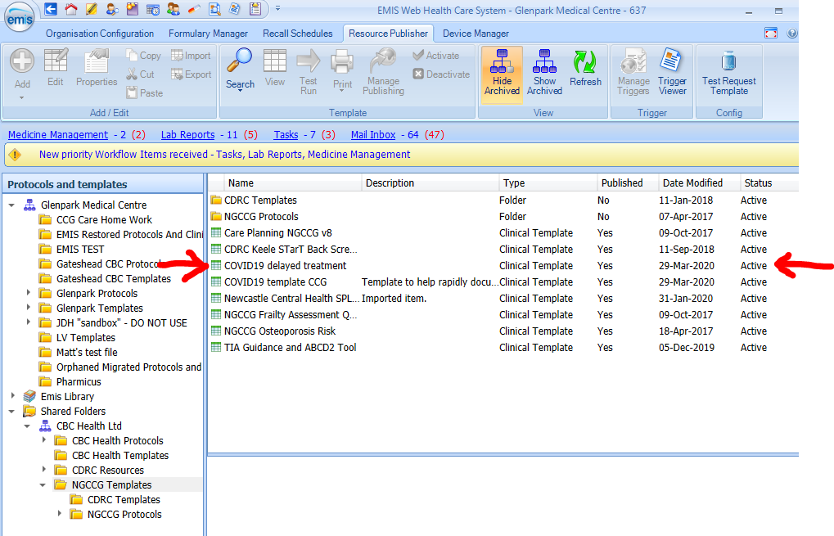

Using the Template
Whenever seeing a patient who needs an intervention but there is a necessary delay due to the current circumstances, click on the run template icon.
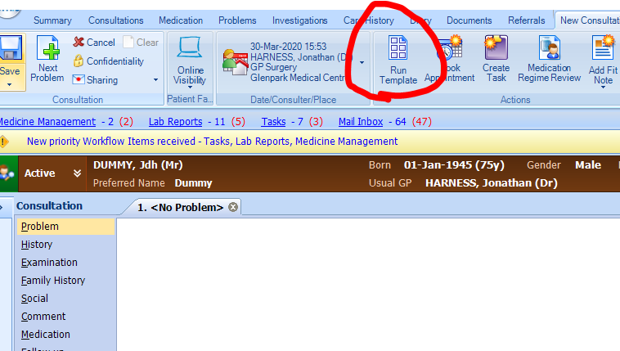
In the template picker, type COVID19 and click search and choose the COVID19 Delayed search template:
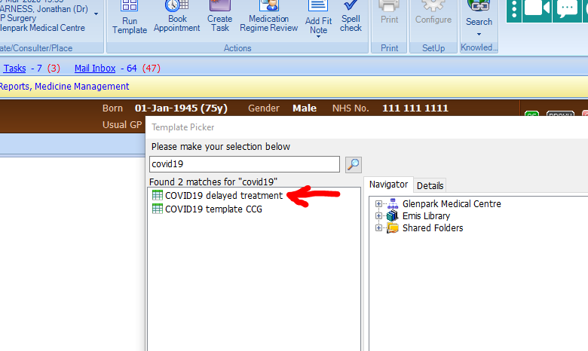
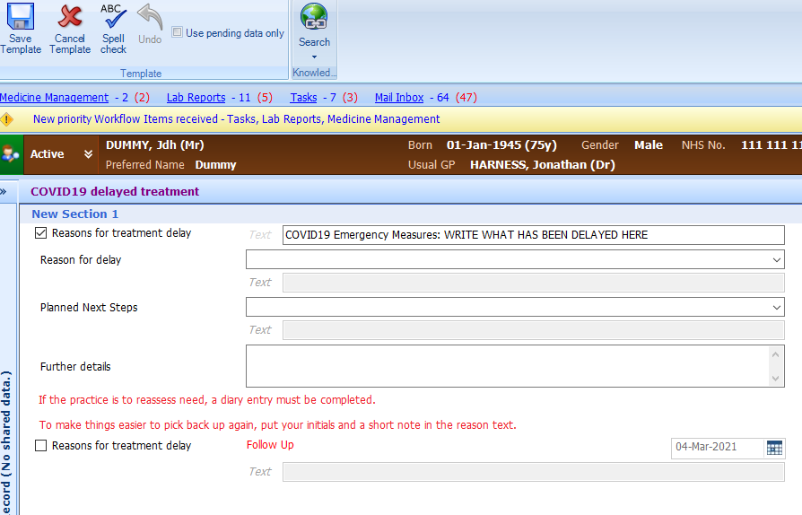
In the first box (already ticked) replace “write what has been delayed here” with whatever treatment will be needed, eg “Echo” or “Referral”. Consider writing the initials of who owns the task
The second drop down list asks for the reason for the delay (eg pt choice, lack of service capacity etc)
The third drop down list gives options for planned next steps, namely:
- Patient will come back to the practice
- The practice will contact the patient and reassess need
- An external service is holding the delay
Further details can be used to write free text as needed.
IMPORTANT: the last option is to create a diary entry. If the practice will be holding the delay and initiating at a future date, this must be ticked and an appropriate future date added

Managing the Delayed Referrals
Someone needs to check the “COVID 19 Delayed Treatment Due or Overdue” list on a regular basis to pick up patients that need reassessment. (Remember that there may be patients who need urgent review even during the surge phase, so this cannot be left under the recovery phase of the pandemic).
How practices manage these tasks is an internal process. However, one approach is to send an urgent task to the person who set up the diary entry or their buddy if they are on leave.
That individual then needs to make a choice:
- Carry the deferment forward (in which case complete the template again with reasons and updated diary entry
- Complete the diary entry (right click over the diary entry in the patient record and click complete

Version Control
Author: Dr Jonathan Harness
Date: 30 March 2020
Version: 1
Status: Draft

