CDRC Delayed Treatment System Guide – SystmOne (S1)
The COVID-19 pandemic has meant that there is a lack of capacity to be able to provide normal referral and treatment pathways, whether this is referral to an outpatient appointment, minor surgery in practice or other.
Certain patients may prefer to delay referral/treatment until the current high risk to the population has improved (including 2ww referrals), rather than risk exposure to infection i.e. the “shielded” very vulnerable group. Furthermore, some patients may be suffering from possible COVID19 symptoms meaning that they are unsuitable at the time for referral, even for 2 week wait referrals, and there needs to be a delay whilst they recover.
The delayed treatment module in DCS provides a structured way to capture any intervention that is delayed. However, the system is not designed to manage patient choice to decline an intervention altogether.
In order to access the resources – please ensure that your organisation has added the DCS Organisational Group - see additional guidance on how to do this.

How do I setup and access the Delayed Treatment System?

How do I record a delay?

How do I ensure that the treatment delay recalls I set are automatically followed up?

How do I setup and access the Delayed Treatment System?
- Navigate to the Recall Types window; then click the New Recall Type button in the top left of the screen:
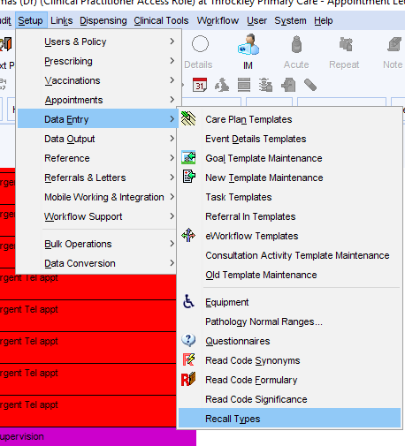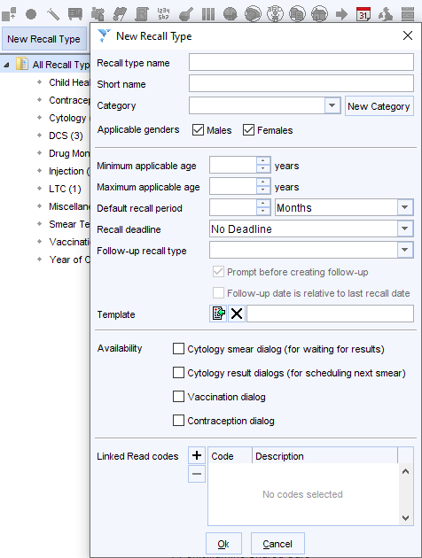
- Type ‘Delayed Treatment’ into the top ‘Recall type name’ box, then click okay (you don’t need to change or add any other values in this window).
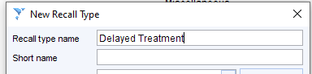

- To open the template, just search for “delay” in the search bar at the bottom left of the screen, then click on the “Delayed Treatment” option (NB you need to have a patient record open in order to open/use the module) :
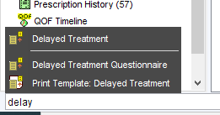

How do I record a delay?
- The Delayed Treatment template shows relevant clinical codes, previous entries and recalls and allows you to record the reasoning behind the delay, the plan for follow up and to add a recall.
- Click the “Record Treatment Delay” button:
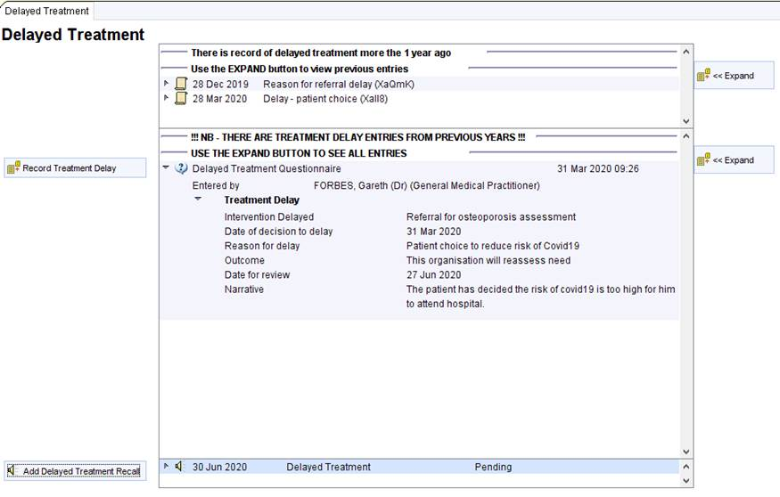

- Complete the short questionnaire. Question 4 about the outcome is mandatory:
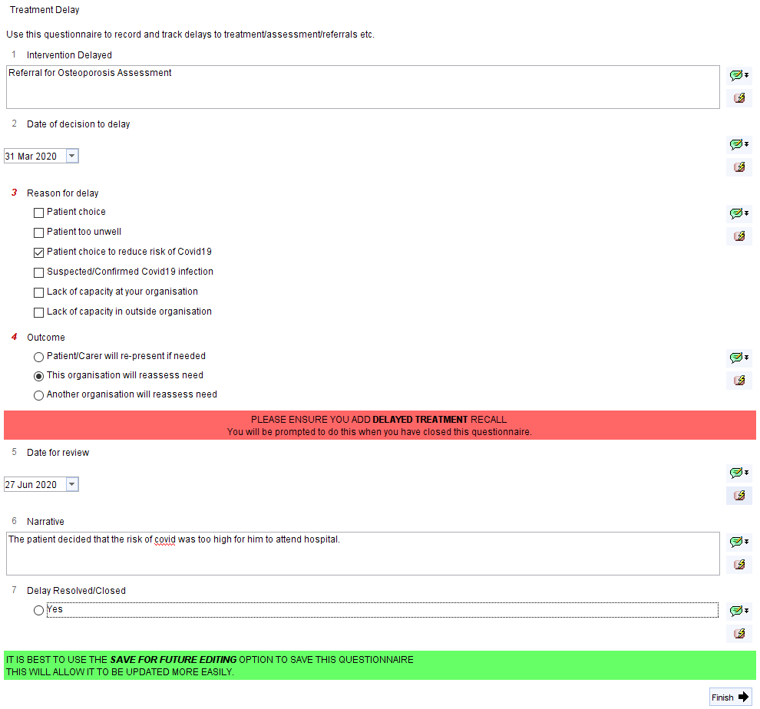
- There are three possible outcomes: the patient, your organisation or another organisation will take responsibility for follow up. If 'your organisation' is chosen, a prompt will recommend the addition of a recall – it is important that this recall is setup as this allows for safe follow up of the recorded delay.
- When the questionnaire is finished, close it by using Save for Future Editing (this will allow updating in future when you come to review the patient’s wishes/decision-making):
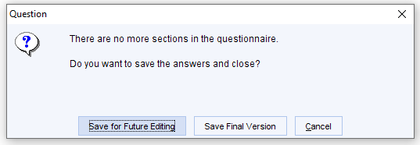
- The “Confirm Treatment Delay” prompt allows you to record a relevant clinical code. Each button corresponds to a separate clinical code which will be recorded in the patient’s record:
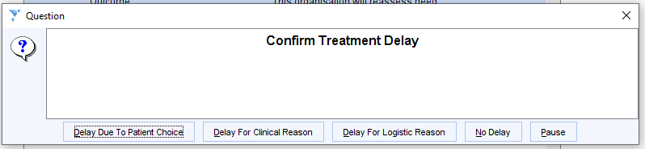
- You are then offered the option to add a Delayed Treatment recall:
  - If your organisation is taking responsibility to organise follow up – you MUST click “Yes” to set a recall so that your organisation is prompted to contact the patient for review.
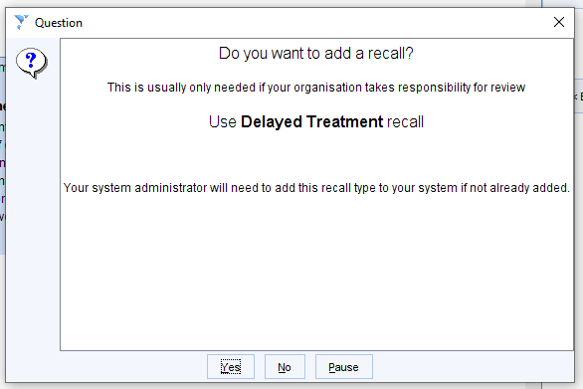
- If you select “Yes” above, the “Create Recall” template opens. Scroll down the “Type” List and select “Delayed Treatment”
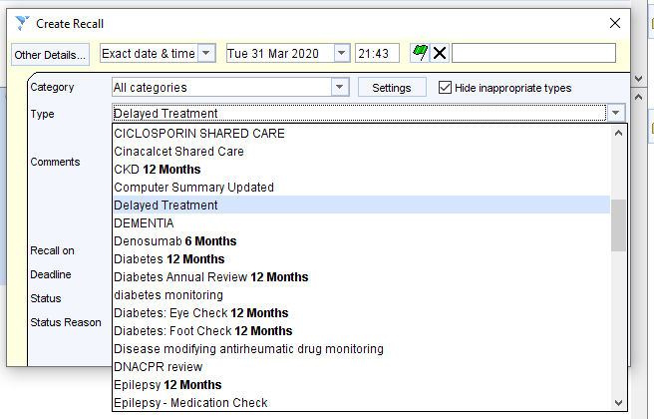
- Then, select the same date in the “Recall on” box, as you did in the treatment delay questionnaire.
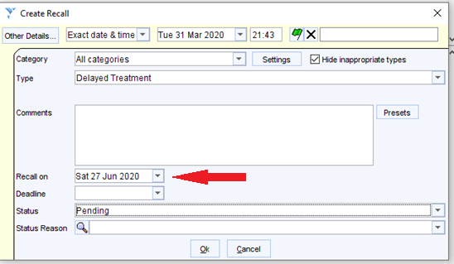

How do I ensure that the treatment delay recalls I set are automatically followed up?
- Open the batch-reporting window:
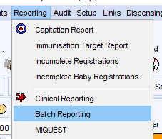
- Click on “Create new Batch” in the top left-hand corner of the window:
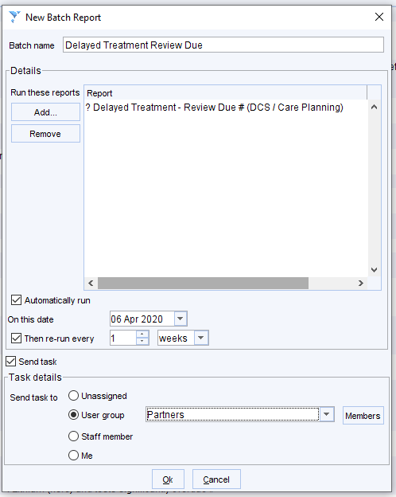
- Add the Batch name.
- Then add the? Delayed Treatment – Review Due # Report as above.
- Set a start date soon– e.g. the next working day, and set the report to run every week
- Assign the task to a User Group relevant & in daily use by your practice to ensure that automatically generated tasks are viewed and actioned in a timely manner.
- Click okay to complete the batch report

- When the record is reviewed, as the recall falls due, the information in the questionnaire can be updated by right clicking on the answers and choosing Amend Questionnaire. NB if the questionnaire was previous saved as 'final version' you will not be able to amend it but you can choose Copy Questionnaire to create a new copy that can be edited.
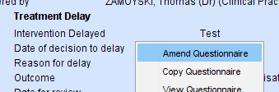

- You can then amend the Narrative to reflect the discussion with the patient:
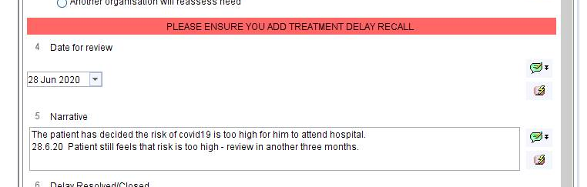
- To amend the recall date, right click on the recall. Use Follow-on/supersede to move the date, use Seen or Cancel once the recall is no longer needed.
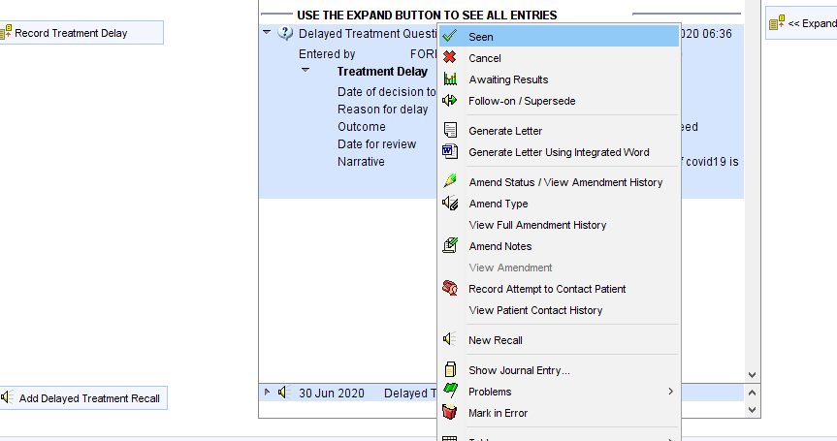

- If the recall is cancelled or marked as seen, the following warning prompts the use to check to see if there are any other outstanding delayed treatments that require ongoing recall.
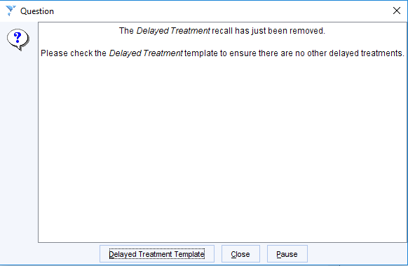

- If you want to run the Delayed Treatment report manually you can find it via the Clinical Reporting unit:
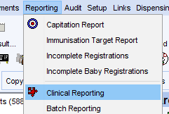
- Search for “delay” and then right click and run the search below:
- 