
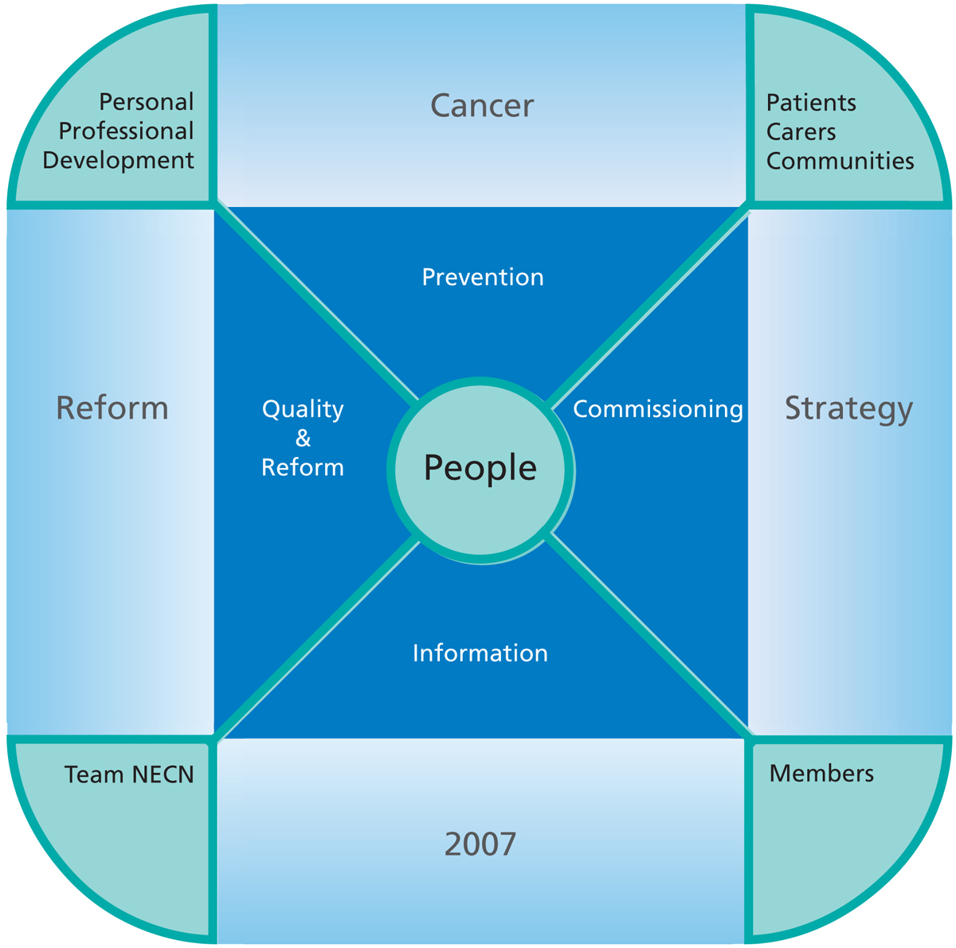
You should leave the GP Practice today with confirmation of a provisionally booked appointment.

My hospital appointment is:

Date:

Time:

Consultant:

Where:
In order to help your specialist understand the cause of your symptoms you may be required to undergo some tests. Depending on the nature of your symptoms these tests may be required at different stages. You may be required to have these tests:
  - Before you see your specialist
  - During your first appointment with the specialist
  - The specialist may refer you for these tests following your first appointment
Details on what will happen at your first appointment, and any tests you might need, will usually be sent with your appointment letter. If you do not receive this information or have any further questions please contact your GP.
You may find it useful to write down any questions you want to ask during your appointment.
The specialist team often give people a lot of information during their appointment and therefore many people find it useful to take a friend or relative along with them. You are very welcome to take someone with you to your appointment.
What will happen at my
appointment?

Urgent
Two-Week Referral
The James Cook University Hospital
Marton Road
Middlesbrough
TS4 3BW

01642 282853/ 01642 854973
(Between 08:30am – 5pm Mon-Fri)

The Friarage Hospital
Bullamoor Road,
Northallerton,
DL6 1JG

01642 282853/ 01642 854973
(Between 08:30am – 5pm Mon-Fri)



For your GP to complete; in the event that there are no appointments available for the service you require:

My NHS Number is:

I saw my GP on:

The speciality I am being referred to is:

The latest date I should expect to be seen by a specialist is:

If I have not received a hospital appointment by

I should contact the hospital on:

01642 282853 or 01642 854973

It is important to remember that even though you are being referred urgently, this DOES NOT necessarily mean that you have cancer.

5
6
Urgent Two-Week Referrals — Your Questions Answered
Why am I being urgently
referred?
What does it mean to be
urgently referred?
How do I get to hospital?

Your GP feels that you have symptoms that require investigation by a hospital specialist as soon as possible. This is so that your illness can be diagnosed and treated quickly and effectively.
Whilst this does include the possibility of cancer, the majority of people referred in this way do not have cancer. The signs and symptoms you have may be caused by a number of common conditions but it is important for you to be seen quickly in order to fully investigate your condition.

An urgent two-week referral means that you will be offered an appointment with a hospital specialist within 2 weeks of your General Practitioner (GP) making the referral.
As of April 1st 2010 you have a legal right to be seen by a specialist within this time. If this is not possible, the NHS must do everything they can to find you an appropriate alternative appointment but you will need to ask them to do this for you. If you are not offered an appointment within 2 weeks of seeing your GP please contact the hospital you have been referred to using the number on the front of this leaflet.
More information can be found in the NHS Constitution leaflet entitled ‘Your right: urgent two-week Referral’ which your GP will have
given to you.
2
How do I make my appointment?
Your GP Practice will offer you a choice of available appointment dates/times for the service that you require before you leave the Practice today.
You should leave the GP Practice with confirmation of a booked appointment.
In the event that there are no appointments available, please ensure that you have provided your GP Practice with a telephone number on which you can be contacted. The hospital will then contact you within 48 hours.
3
What if I cannot make the
appointment I am offered?
Your GP believes that your symptoms need to be investigated as soon as possible so it is important that you are flexible when arranging this appointment and make every effort to attend the appointment you are given.
However, if you cannot make the appointment you are given, please contact the hospital as soon as possible using the number on the front of this leaflet so an alternative can be arranged.
If you cancel an arranged appointment or do not attend your appointment, your hospital will do their best to ensure you are seen as soon as possible, but you will no longer be covered by your right to be seen by a specialist within 2 weeks as described in the NHS Constitution.
If you cannot use public transport, drive or arrange your own transport you may be able to use the ambulance service. NHS Tees Patients should contact the Transport Information Service on 0345 045 0160. NHS County Durham and Darlington or NHS North Yorkshire and York patients should contact your GP Practice.

4

