

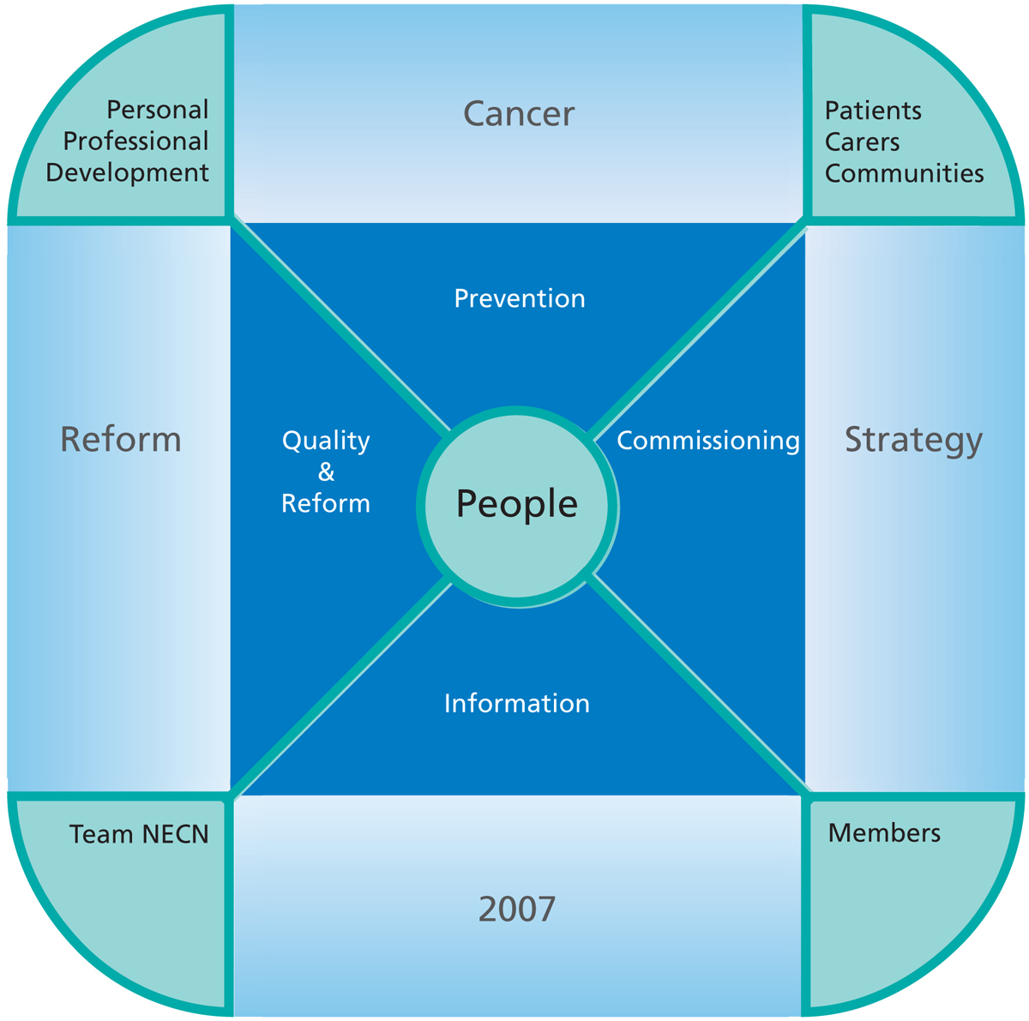
In order to help your specialist understand the cause of your symptoms you may be required to undergo some tests. Depending on the nature of your symptoms these tests may be required at different stages. You may be required to have these tests either:
before you see your specialist,
during your first appointment with the specialist,
or the specialist may refer you for these tests following your first appointment.
Details on what will happen at your first appointment, and any tests you might need, will usually be sent with your appointment letter. If you do not receive this information or have any further questions please contact your GP.
You may find it useful to write down any questions you want to ask during your appointment. The specialist team will give you a lot of information and many people find it useful to take a friend or relative along with them and you are very welcome to do so.
What will happen at my
appointment?

5
Urgent
Two-Week Referral

For your GP to complete

My NHS Number is:

I saw my GP on: (Date)

The speciality I am being referred to is:

The latest date I should expect to be seen by a specialist is:
(Date)

If I have not received a hospital appointment by (Date)
I should contact the hospital on:

0191 427 7575

It is important to remember that even though you are being referred urgently, this DOES NOT necessarily mean that you have cancer.

South Tyneside District Hospital
Harton Lane
South Shields
Tyne and Wear NE34 0PL

Your Address Line 4

For you to complete

(When your appointment has been agreed with the hospital)

My hospital appointment is:

Date:

Time:

Consultant:

Where:

6
1

How do I make my
appointment?
For appointments at South Tyneside your GP practice can make an appointment while you are in the surgery through something called choose and book.
If the GP decides to fax a referral letter to us instead you will be contacted by someone in our appointments centre. If you have not heard within 7 days of seeing your GP please contact the appointments centre on
0191 427 7575
How do I get to
hospital?
If you cannot use public transport, drive or arrange your own transport you may be able to use the ambulance service. Please speak to the receptionist at your GP surgery as soon as possible if ambulance transport is required.

Your GP feels that you have symptoms that require investigation by a hospital specialist as soon as possible. This is so that your illness can be diagnosed and treated quickly and effectively.
Whilst this does include the possibility of cancer, the majority of people referred in this way do not have cancer. The signs and symptoms you have may be caused by a number of common conditions but it is important for you to be seen quickly in order to fully investigate your condition.

Why am I being urgently
referred?
Urgent Two-Week Referrals — Your Questions Answered
What does it mean to be
urgently referred?
An urgent two-week referral means that you will be offered an appointment with a hospital specialist within 2 weeks of your General Practitioner (GP) making the referral.
As of April 1st 2010 you have a legal right to be seen by a specialist within this time. If this is not possible, the NHS must do everything they can to find you an appropriate alternative appointment but you will need to ask them to do this for you. If you are not offered an appointment within 2 weeks of seeing your GP please contact the hospital you have been referred to using the number on the front of this leaflet.
More information can be found
in the NHS Constitution leaflet
entitled “Your right: urgent
two-week referral” which your
GP will have given to you.

2
3
What if I cannot make the
appointment I am offered?
Your GP believes that your symptoms need to be investigated as soon as possible so it is important that you are flexible when arranging this appointment and make every effort to attend the appointment you are given.
However, if you cannot make the appointment you are given, please contact the hospital as soon as possible using the number on the front of this leaflet so an alternative can be arranged.
If you cancel an arranged appointment or do not attend your appointment, your hospital will do their best to ensure you are seen as soon as possible, but you will no longer be covered by your right to be seen by a specialist within 2 weeks as described in the NHS Constitution.
4

